China is stoking anger over Japan’s release of nuclear wastewater

The feud may have more to do with politics than health

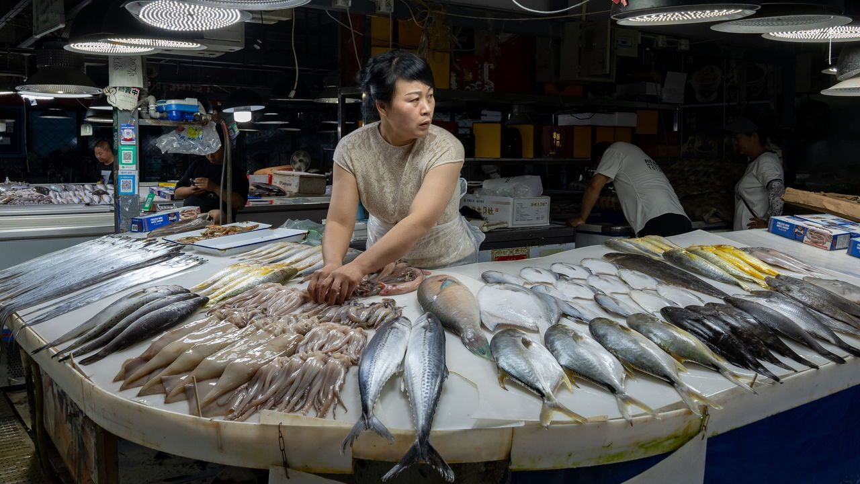

image: getty images

On august 24th the government of Japan began releasing water into the ocean. This is not just any water, mind you, but treated wastewater from the Fukushima nuclear plant,

which was destroyed 12 years ago by a tsunami. Japan has dealt with the situation carefully, putting the liquid through an advanced filtration and dilution process. It still contains a potentially harmful radionuclide called tritium. But experts say the levels are so low that this is not a concern. Japan wants to release more than a million tonnes of the water over the next 30 years. Many scientists back the plan, as does the un’s International Atomic Energy Agency.

在8月24日，日本政府开始向海洋释放水。这不仅仅是普通的水，而是经过福岛核电站废水处理的水，该核电站在12年前被海啸摧毁。日本以谨慎的态度处理了这个问题，通过先进的过滤和稀释过程处理了废水。尽管废水中仍含有一种潜在有害的放射性核素，即氚，但专家表示其浓度非常低，不会引发担忧。日本计划在未来30年内释放超过一百万吨的水。这一计划得到了许多科学家以及联合国国际原子能机构的支持。

China, though, has blasted Japan’s actions, calling them reckless. The government has banned imports of Japanese seafood. State media has endlessly covered the story, with little mention of the scientists who support the

plan. Nationalist netizens have taken it from there, calling for a boycott of Japanese goods.

A few Chinese cities have experienced a salt-buying frenzy, with people queuing for hours to purchase a bag. Some seem to think that salt may become tainted or that it is useful in treating radiation sickness.

然而，中国对日本的行动进行了严厉批评，称其行为鲁莽。中国政府已经禁止进口日本海产品。国家媒体对此事进行了广泛报道，但很少提及支持该计划的科学家。一些中国城市出现了购买食盐的疯狂现象，人们排队数小时以购买一袋食盐。一些人似乎认为食盐可能会受到污染，或者具有治疗辐射病的功效（实际上并非如此）。

There are, to be sure, scientists and environmental activists who also oppose Japan’s plan. Some claim that more studies are needed to assess the potential impact. Others say that the authorities in Japan are not to be trusted. The disaster in Fukushima exposed alarming levels of official corruption, incompetence and deception.

But China’s response may have more to do with politics than anything else. Anti-Japanese sentiment in the country runs deep. Chinese

nationalists often invoke Japan’s invasion and occupation of China during the 1930s and

1940s. A dispute over five islets in the East China Sea a decade ago led to talk of war. More recently, officials in Beijing have watched with frustration as Japan draws closer to America. On the wastewater issue, Japan says China has rebuffed its offers to hold meetings where it would address any worries.

可以肯定的是，确实有一些科学家和环保活动家反对日本的计划。他们中的一些人声称需要进行更多研究来评估潜在的影响。还有人称日本当局不可信。福岛核灾揭示了令人震惊的官方腐败、无能和欺骗行为。

A different type of meeting has also complicated the situation. On August 18th President Joe Biden hosted Japan’s prime minister, Kishida Fumio, and South Korea’s

president, Yoon Suk-yeol, for an

unprecedented summit. A rancorous history has often divided Japan and South Korea. China’s assertiveness has brought them closer.

Now, though, China may spy an opportunity

to drive a wedge between them. South Korea’s

government has supported Japan’s wastewater plan, but the Korean opposition and much of the public are against it. (The Japanese public is also divided on the issue.)

For China, the wastewater release has come at a convenient time. The country’s economy is struggling. Each week seems to bring a new batch of disappointing data. Japan’s actions have provided a distraction from the bad news.

But concerns about the economy may undermine China’s response. No country buys more seafood from Japan. The ban on imports risks hurting Chinese businesses nearly as much as Japanese fishermen. It may not last long.

另外一种会议也使情况变得复杂。在8月18日，美国总统乔·拜登主持了一次前所未有的峰会，邀请了日本首相岸田文雄和韩国总统尹锡悦。历史上，日本和韩国之间经常存在不和谐的关系，而中国

的强硬立场使两国更加接近。然而，现在中国可能看到了一个机会，试图在他们之间制造分裂。韩国政府支持日本的废水计划，但是韩国的反对派和大部分民众都反对这一计划。（日本国内对此问题也存在分歧。） 对于中国来说，日本废水的释放恰逢其时。该国的经济正处于困境中，每周都会出现一批令人失望的数据。日本的行动提供了一个转移注意力的机会，让人们暂时忘记了这些坏消息。然而，对经济问题的担忧可能会削弱中国的反应。中国是从日本购买海产品最多的国家之一，进口禁令的实施可能会对中国企业造成与日本渔民相当的损失。这种情况可能不会持续太久。